1.Dependencies description

implementation fileTree(**dir**: **"libs"**, **include**: [**"*.jar"**]

It extends FileCollection to add hierarchy query and manipulation methods.

implementation **'androidx.appcompat:appcompat:1.2.0'**

AppCompat is a set of support libraries which can be used to make the apps developed with newer versions work with older version

implementation **'androidx.constraintlayout:constraintlayout:2.0.0'**

Add constraint layout in android studio

implementation **'com.google.android.gms:play-services-maps:17.0.0'**

implementation **'com.google.android.gms:play-services-location:17.0.0'**

implementation **'com.google.android.libraries.places:places:2.3.0'**

implementation **'com.google.android.gms:play-services-places:16.1.0'**

These four dependencies is to add google map to android studio

implementation **'androidx.legacy:legacy-support-v4:1.0.0'**

implementation **'com.android.support:design:27.1.0'**

It adds to your Android application in order to use APIs that are either not available for older platform versions or utility APIs that aren't a part of the framework APIs.

implementation **'com.amplifyframework:core:1.1.2'**

implementation **'com.amplifyframework:aws-datastore:1.1.2'**

implementation **'com.amplifyframework:aws-api:1.1.2'**

implementation **'com.amplifyframework:aws-storage-s3:1.1.2'**

implementation **'com.amplifyframework:aws-auth-cognito:1.1.2'**

These five dependencies can add AWS amplify api in android studio. Also add datastore, s3 storage and authorization api into android studio

coreLibraryDesugaring **'com.android.tools:desugar_jdk_libs:1.0.10'**

Support for Java 8 features and support java lambda function

implementation **'com.theartofdev.edmodo:android-image-cropper:2.6.0'**

These dependencies can help users to crop images.

implementation **'com.google.mlkit:image-labeling-automl:16.2.0'**

Using google ML Kit to train model

implementation **'com.github.denzcoskun:ImageSlideshow:0.0.7'**

Add function of image slider

implementation **'com.google.android.material:material:1.2.1'**

Add material UI to android studio project

implementation **'com.github.PhilJay:MPAndroidChart:v3.1.0'**

Add bar chart and pie chart on Android Studio

2.API description



Using Google Map API to locate user

3. Code

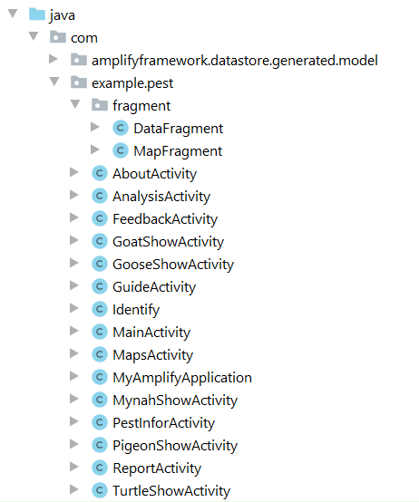

4. Layout XML File

